Interactive game system with computer controlled characters

Third Progress Report

New completed tasks:

The game engine now supports collision detection, preventing the user ‘walking through walls’ it also allows for a simple form of gravity and the ability to walk up and down steps and slopes.

The AI unit now simply displays a 3D model of a computer-controlled character (CCC), and rotates the character. Now that this is in place, the next step is to make the character move around the environment and sense if the user is within its sights.

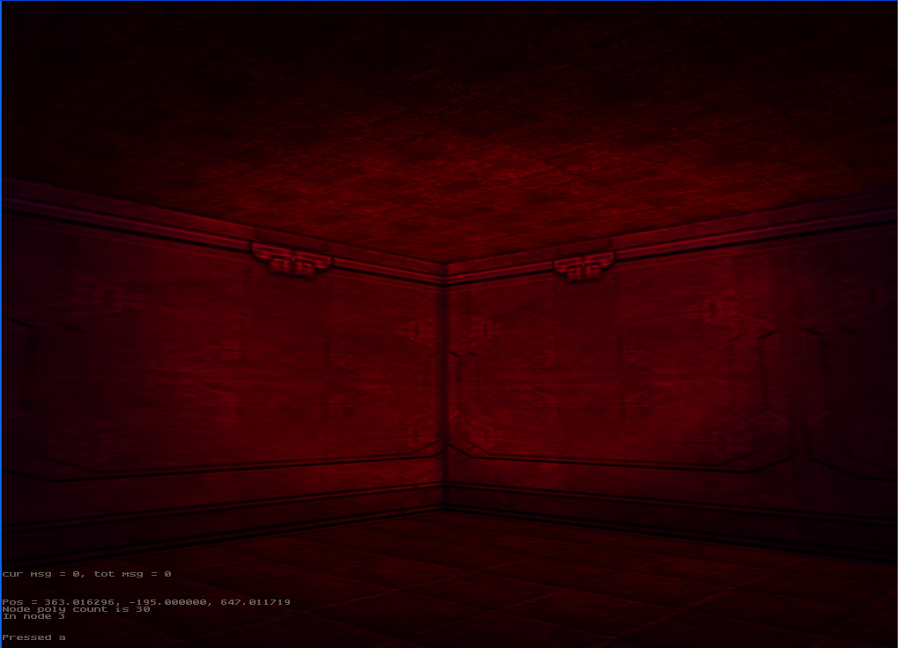
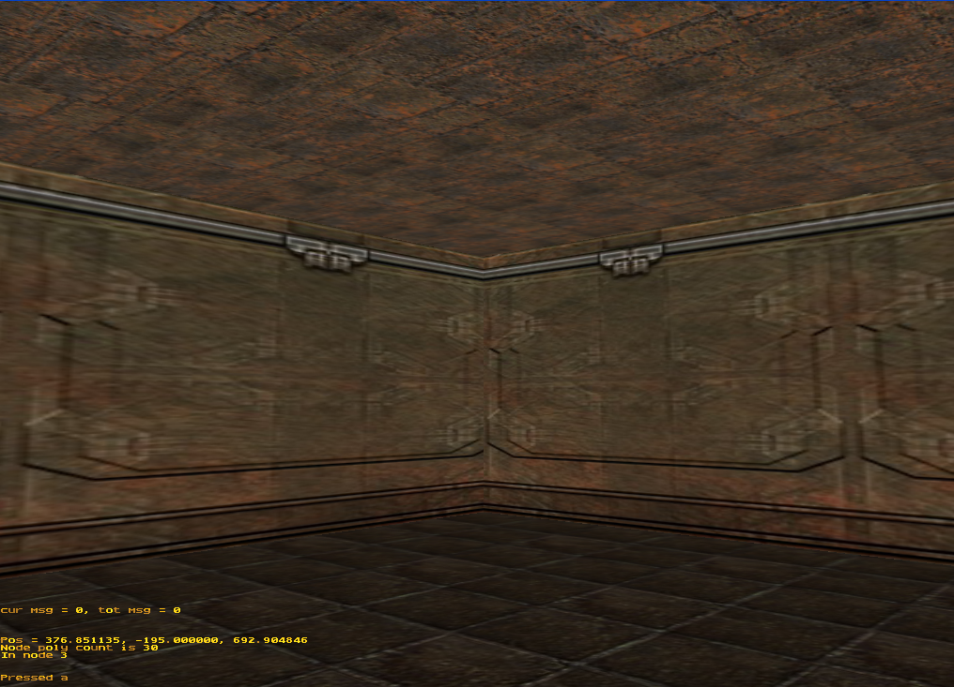
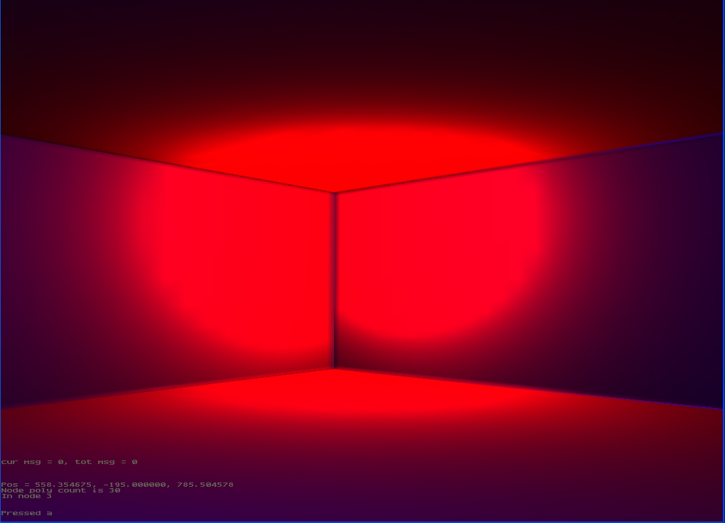
Tasks being completed:
Figure 1: Light Mapping (from left to right: texture only, light map only, texture + lightmap)

The lighting within the renderer is going to be based around the technique of light mapping. This is a process whereby each polygon in a game level has a light map precalculated. This light map represents the intensity of the light at each point within the polygon. Combining the light map with the polygons original texture gives the impression that a light is shinning onto the wall.

This process has meant a new tool needed to be created. Each static light is taken in turn and checked to see if it hits each polygon, if the light reaches the polygon, then the intensity of the light at each point within that polygon is calculated and saved at the relevant position in that polygons light map.

The Next Step:

Once the light mapping is finished, the main remaining implementation task is controlling the CCC’s.

The Changes to the Gantt Chart:

There have been small changes to the Gantt chart that reflect the progress so far, one is that the implementation time has been extended to the end of February, which means that there is around two weeks to implement the basic CCC. Also debugging and testing has been extended to reflect the fact that this process has been going on throughout the implementation phase and will continue after the implementation has finished.

